## **. Chapter Overview**

The domain related to this study is machine learning techniques to predict the best diabetes prediction application for people. Via this section literature has been established and checked in the above domains. To address our work void, it was undertaken to establish an interpretation of the problem background and machine learning methods to forecast more precise outcomes that were already in place and applied by experts. And thorough review of each primary subject will be subsequently given by this Literature Review.

## **2.2. Domain Justification**

### **2.2.1. Diabetes**

Diabetes is a disease that is known as blood sugar if you get too much blood glucose. Too much glucose growing causes health problems in your blood over time. People should take steps to control your diabetes and stay healthy since diabetes has no cure. (Report, 2020). There are three major types of diabetes- type 1, type 2, and gestational diabetes (Anon., December 2016).

#### **2.2.2. Factors That Affect Diabetes**

Once the diabetes is detected and if it is not cured for a longer period then it can mainly affect eyes, kidneys, skin, and heart. There are several important diabetes risk factors. Although human genetics can pose some diabetic threats, many are preventable. Sadly, many people do not know or understand the major risk factors and symptoms of them clearly. A list of the top risk factors and symptoms for diabetes display below.

Table 3:Factors That Affect Diabetes

|  |  |
| --- | --- |
| Symptoms | Risk Factors |
| Polydipsia | Obesity |
| Polyuria | Lack of exercise and sedentary way of life |
| Fatigue | High blood pressure |
| Dizziness | Gestational diabetes |
| Weight Loss | Family history |
| Blurred Vision | Aging |
| Slow Healing | Pregnancy |
| Genital Itchiness | Smoking and alcohol |
| Nausea | Race/ethnic background |

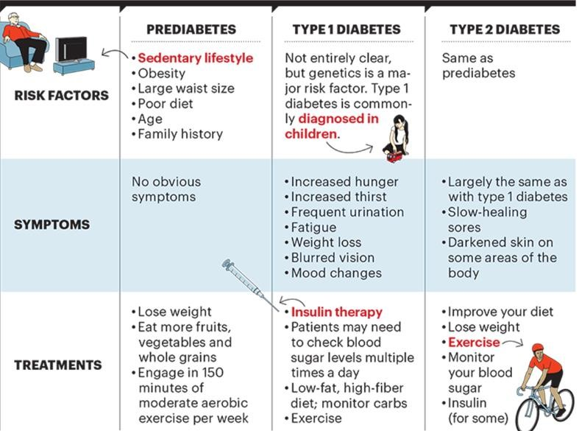

## **2.6 Chapter Summery**

This chapter explains mainly recognized research sectors. How diabetes prediction application is important to diabetes patients and what are the main fields that that have a direct effect on human health are described with research details. Also, major factors of diabetes predicting result, further education of diabetes prediction are discussed in the domain. Choosing a mobile solution to how it affects the user’s usability and how accurate using a mobile solution also explains in this chapter. Also, what are the machine learning technologies used to develop and improve this application, what are the existing systems and related to the proposed application are given in this chapter.